LAB ASSIGNMENT 02
DESIGN AND ANALYSIS OF ALGORITHM

NAME - NILABH KISHORE GUPTA
GROUP - 2Q12
ROLL NUMBER - 1024170059

QS 1 CODE

//Consider an array arr[] = {2, 5, 8, 12, 16, 23, 38, 56, 72, 91} and use Binary Search to find
//the target 23.

#include <iostream>
using namespace std;

int binary_search(vector<int>nums, int target){
int start = 0;
int end = nums.size() - 1;

while(start <= end){
int mid = start + (end - start)/ 2;

if(target == nums[mid]){
return mid;
}

else if(target > nums[mid]){
start = mid + 1;
}

else{
end = mid - 1;
}
}

return -1;
}

int main(){
vector<int>arr = {2, 5, 8, 12, 16, 23, 38, 56, 72, 91};
int ans = binary_search(arr,23);
cout << ans << endl;
return 0;
}

OUTPUT

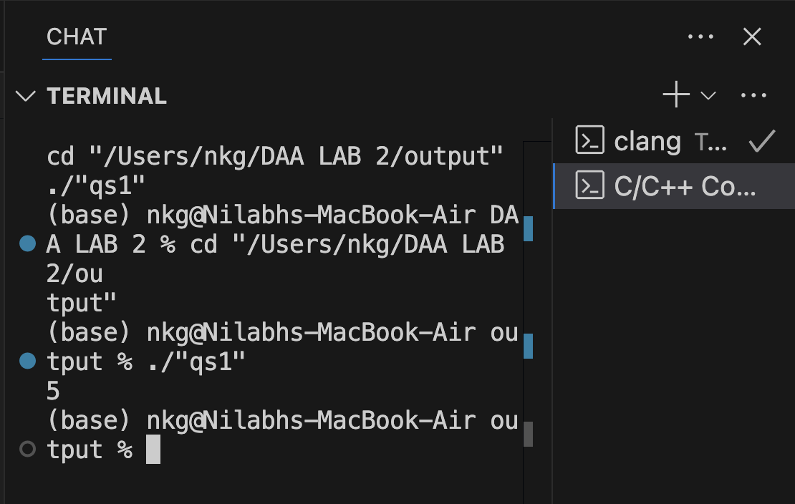

QS 2 CODE

// Implement Merge sort for the given array int arr[] = {12, 11, 13, 5, 6, 7}. After implementing
// Merge Sort, apply the same implementation to sort another array: int arr2[] = {38, 27, 43,
// 3, 9, 82, 10}.

#include <iostream>
using namespace std;

void merge(int arr[], int start, int mid, int end){
int temp[100];
int index = 0;
int left = start;
int right = mid+1;

while(left <= mid && right <= end){

if(arr[left] <= arr[right]){
temp[index] = arr[left];
left++;
index++;
}

else{
temp[index] = arr[right];
right++;
index++;
}
}

while(left <= mid){
temp[index] = arr[left];
left++;
index++;
}

while(right <= end){
temp[index] = arr[right];
right++;
index++;
}
index = 0;
for(int i = start; i <= end; i++){
arr[i] = temp[index];
index++;
}
}

void mergesort(int arr[], int start, int end){
if(start >= end){
return;
}

int mid = start + (end - start) / 2;

mergesort(arr,start,mid);
mergesort(arr,mid+1,end);
merge(arr,start,mid,end);
}

int main(){
// int arr[6] = {12, 11, 13, 5, 6, 7};
// int size = 6;
int arr[7] = {38, 27, 43, 3, 9, 82, 10};
int size = 7;

for (int i = 0; i < size; i++){
cout << arr[i] << " ";
}
cout << endl;

mergesort(arr,0,size-1);

for (int i = 0; i < size; i++){
cout << arr[i] << " ";
}
cout << endl;
return 0;
}

OUTPUT

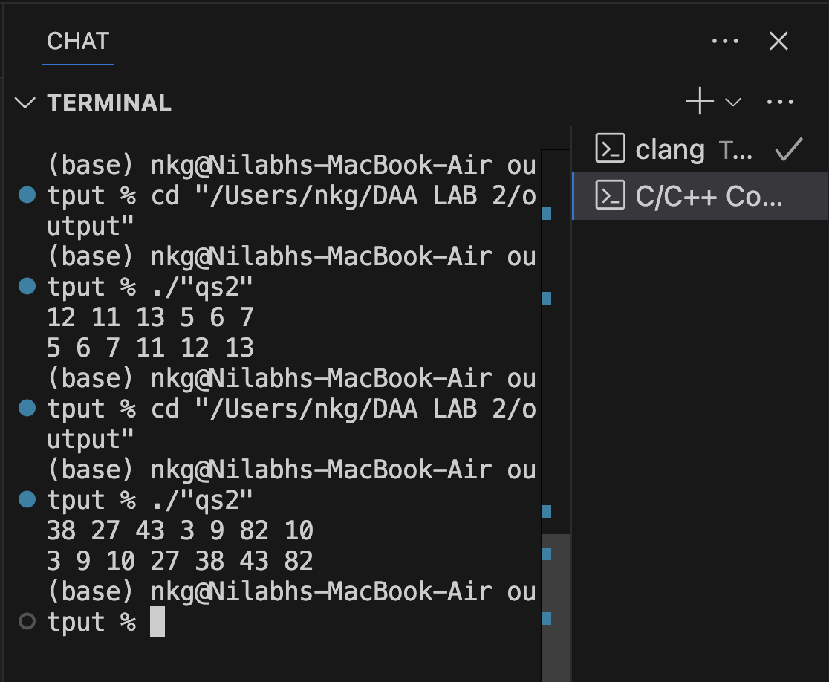
QS 3 CODE

//3. Implement Quick Sort for
//arr[n] = { 4, 2, 6, 9, 2 }

#include <iostream>
using namespace std;

int partition(int arr[], int start, int end){
int pos = start;

for(int i = start; i < end; i++){
if(arr[i] <= arr[end]){
swap(arr[i], arr[pos]);
pos++;
}
}

swap(arr[pos], arr[end]);
return pos;
}

void quicksort(int arr[], int start, int end){
if (start >= end)
return;

int pivot = partition(arr,start,end);

quicksort(arr,start,pivot-1);
quicksort(arr,pivot+1,end);

}

int main(){
int arr[5] = { 4, 2, 6, 9, 2 };
quicksort(arr,0,4);

for(int i = 0; i < 5; i++){
cout << arr[i] << " ";
}

cout << endl;
return 0;
}

OUTPUT

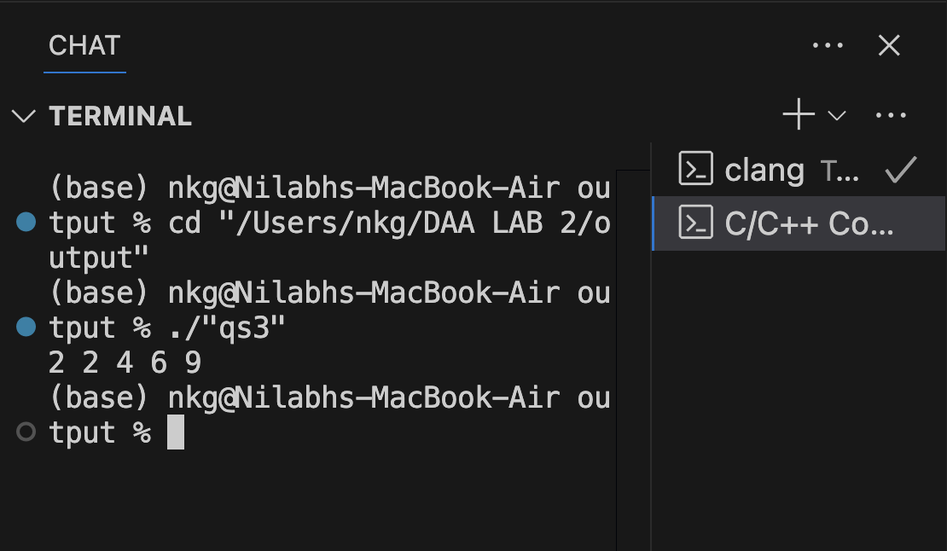

QS 4 CODE

//You are given a 1D array that may contain both positive and negative integers, and find
//the sum of a contiguous subarray of numbers which has the largest sum. For example, if
//the given array is {-2, -5, 6, -2, -3, 1, 5, -6}, then the maximum subarray sum is 7.

#include <iostream>
#include <climits>
using namespace std;

int maxSubArray(vector<int>& nums) {
int currentSum = nums[0];
int maxSum = nums[0];

for (int i = 1; i < nums.size(); i++) {
currentSum = max(nums[i], currentSum + nums[i]);
maxSum = max(maxSum, currentSum);
}
return maxSum;
}

int main(){

vector<int>nums = {-2, -5, 6, -2, -3, 1, 5, -6};
int ans = maxSubArray(nums);
cout << ans << endl;
return 0;

}
OUTPUT

